31.31: a) At resonance:
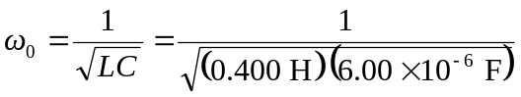
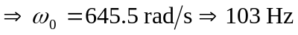.
b)

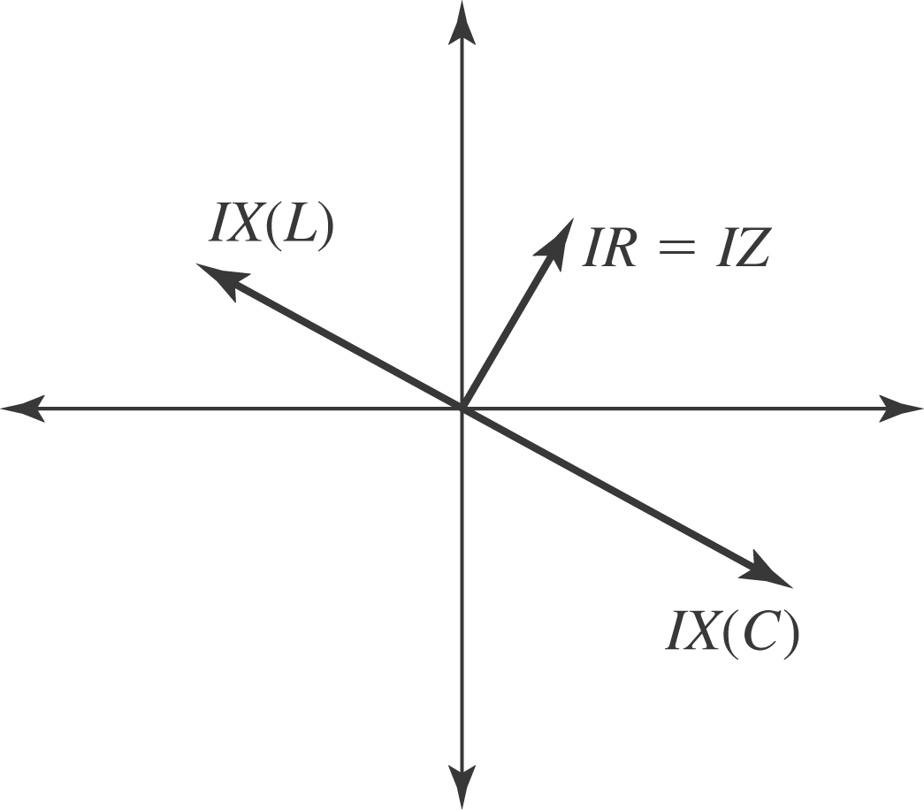

c) 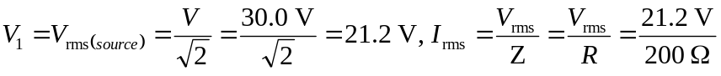
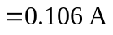
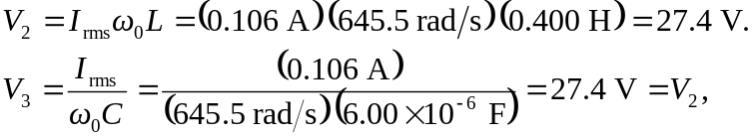
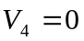, since the capacitor and inductor’s voltages cancel each other.
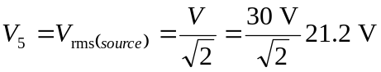.
d) If the resistance is changed, that has no affect upon the resonance frequency:
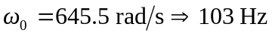
e) 

